**<https://www.typescriptlang.org/docs/>**

**https://angular.io/start**

**https://www.youtube.com/playlist?list=PL7uSdb_U7Fu8XlgXvBUOXyOE2Z_1B-jt9**

**Advantages of Single-Page Applications**

* Fast and responsive.
  + Since single-page applications don't update the entire page but only required content, they significantly improve a website's speed. ...
* Caching capabilities. ...

SQL

Server

Web API

Angular/React

UI

Comp, Services

* Linear user experience. ...
* Debugging with Chrome. ...

**Disadvantages of Single-Page Applications**

* Search Engine optimization is difficult
* Browser history
* Security issues

**TypeScript**

* Types by Inference
* Defining Types
* Composing Types
* Generics
* Structural Type System

**Single Page Application Lifecycle**

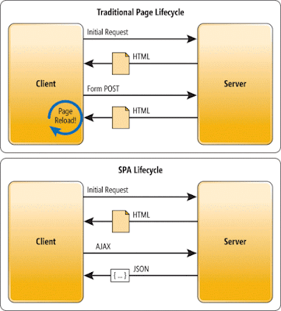

**Explain the need and benefits of Angular**

An Angular framework makes it easy to develop web applications. Combining dependency injection, declarative templates, end-to-end tooling, and integrated best practices, it solves almost all the challenges when creating a web app.

**Describe the difference between AngularJS and Angular**

<https://www.tutorialspoint.com/difference-between-angularjs-and-angular>

| **Sr. No.** | **Key** | **AngularJS** | **Angular 2,3,……. ,11,12,13,14** |
| --- | --- | --- | --- |
| 1 | Architecture | AngularJS works on MVC, Model View Controller Design. Here View shows the information present in the model and controller processes the information. | Angular uses components and directives. Here component is directive with a template. |
| 2 | Language | AngularJS code is written in javascript. | Angular code is written in typescript. |
| 3 | Mobile | AngularJS code is not mobile friendly. | Angular develped applications are mobile browser friendly. |
| 4 | Expression syntax | {{}} are used to bind data between view and model. Special methods, ng-bind can also be used to do the same. | () and [] attributes are used to bind data between view and model. |
| 5 | Dependency Injection | DI is not used. | Hiearchical DI system is used in Angular. |
| 6 | Routing | @routeProvider.when, then are used to provide routing information. | @Route configuration is used to define routing information. |
| 7 | Management | AngularJS project is difficult to manage with increasing size of the source code. | Angular code is better structured, is easy to create and manage bigger applications. |

**Some basic node package manager and angular commands**

**>npm –version**

**>npm update npm –g**

**>npm install -g @angular/cli**

**>ng new projectName**

**>ng add @ng-bootstrap/ng-bootstrap**

**>cd projectName**

**>code . //Opens our app in VS.Code**

**>ng serve**

**>ng serve –o //Build and launch our default app**

**>ng generate component componentName**

**>ng g c componentName/ChildComponentName**

**>ng generate class User/Product/Trainee**

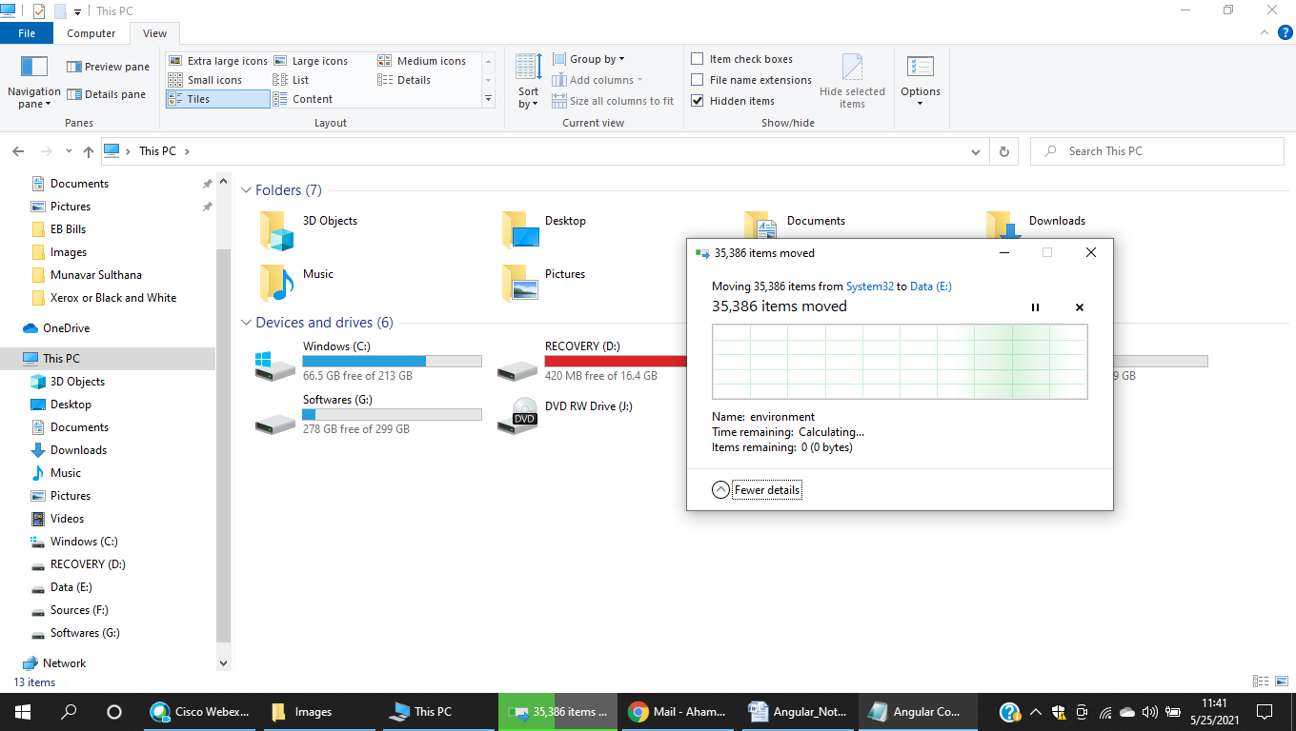

Packages.json – all the dependencies, libraries and modules require for our app.

Node_modules – contains all the packages installed for our app & and services ex. **ng serve**

**src folder**

* main.ts – entry point of our ng application. It will refer **AppModule** in **src/app**/app.module.ts

**src/app folder**

* app.module.ts – root module(contains @NgModule with declarations, imports, providers, bootstrap array definitions)
* app.component.ts – root component (contains component decorator and a class. Class properties will be bind with template expressions. Ex {{title}})
* app.component.html (contains html template code embedded with expressions)

**Note :** Component decorator function contains – selector, templateUrl, styleUrls metadata

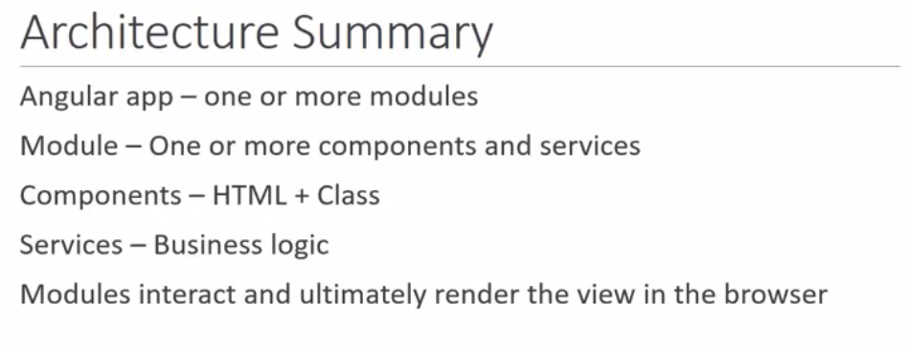

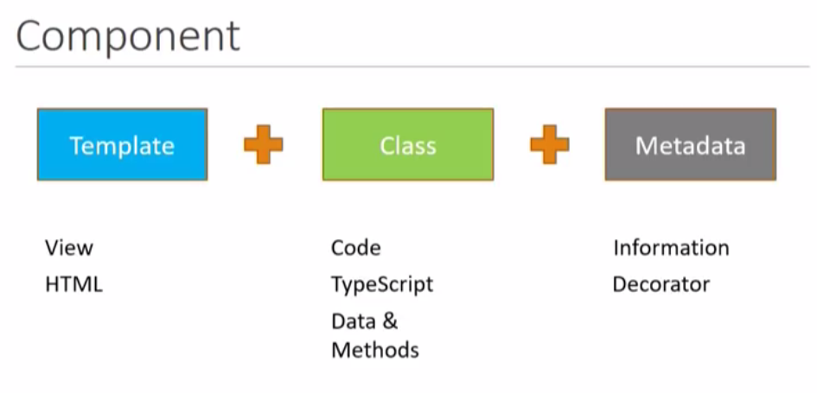

Components are building blocks of Angular Application (Component Decorator + Class).

They Can be created by **ng g c test** will create 4 files (.ts, .spec.ts, html and css files) and also add one import line on root module app.module.ts and one declaration as TestComponent

**Different methods of consuming components in app.compotents.html**

1) As a custom HTML tag

Default one…

2) As a css class

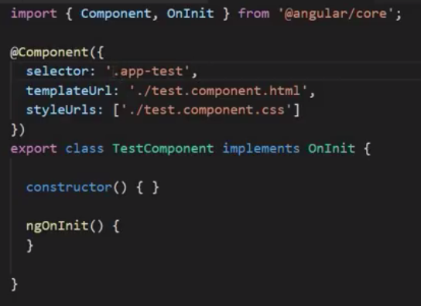

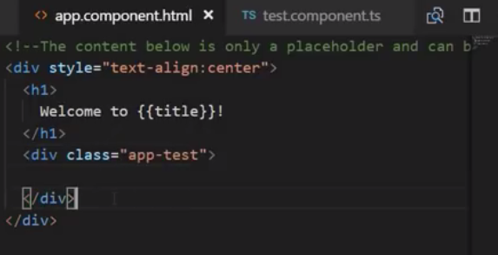

3) As an attribute

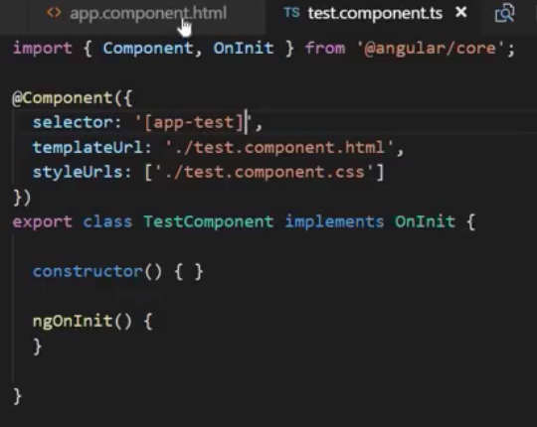

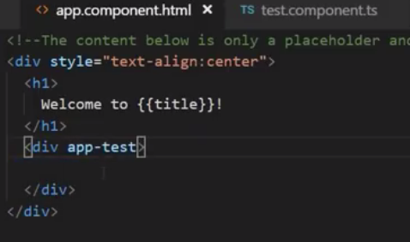

**Template and StyleUrls**

html and css files can be separate files or they can be inline in component.ts file

Inline html – single Line (TemplateURL => template)

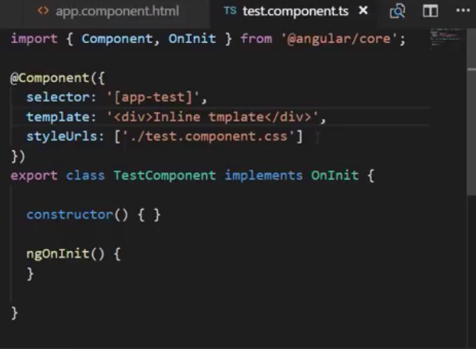

Inline html – Multiline (TemplateURL => template and using back-tick chars)

